aidt | presentation

Pharma/Bioscience Workforce Development

Tapping Into the Bioscience Technician Talent Pool A “How To” Guide in 3 Easy Steps

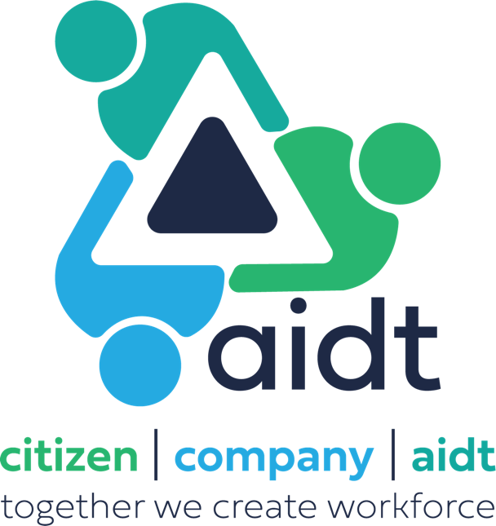
Background
Bioscience Technician Talent Pool – Application Process Overview

Program officially rolled out by Governor Ivey 18Aug2023
- GovGovernor Ivey Announces State Backed Bioscience Training Program - Office of the Governor of Alabama

Interested individuals apply through AIDT using a registration link posted across multiple social media outlets (Facebook, LinkedIn, Instagram), posted in print media, etc.
- Bioscience Technician in Statewide, Alabama | Skills Training at AIDT

Accepted applicants allotted 7 days to complete ~3-hour on-line, self-paced, module-based training course focused on cGXP basics/key skills and aimed at determining if a Bioscience Technician career is the right fit
- Topics covered: Clean room mindset, why do we clean/gown, PPE requirements, life science safety, common pharma/bioscience equipment, pharma/bioscience acronyms, math/significant figures, reading comprehension, attention to detail, and more

Quizzes established for each training module; Comprehensive test required upon completion
- Passing grade of 70 required for successful applicant entry into industry-viewable talent pool
- 387 applicants as of 08Jan2024!!

How to Tap Into Bioscience Technician Talent Pool – Step 1

Access the AIDT company survey link to determine eligibility (Active QR code below)
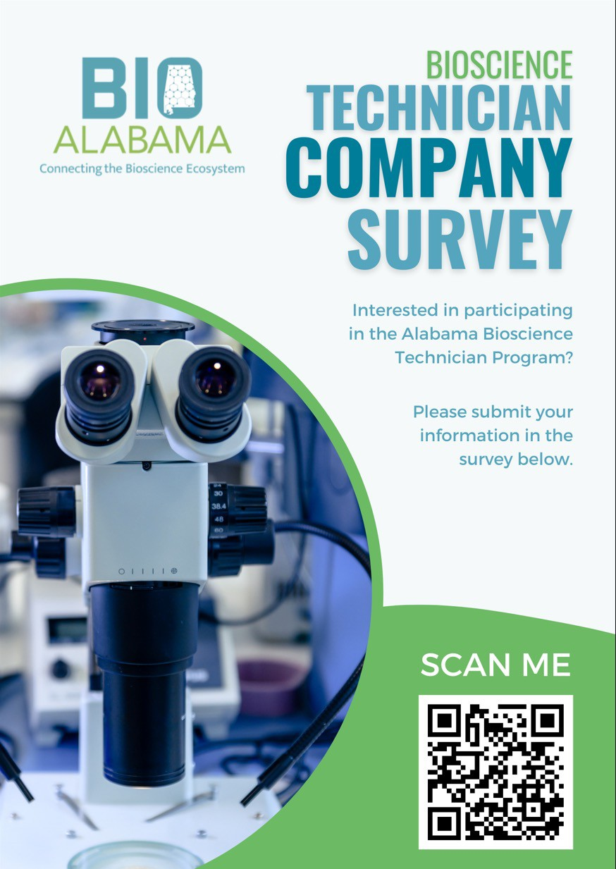
- Establishes physical location, i.e., Alabama-based, primary company contact information, entry-level salary range, position type, number of openings, etc. (9 questions – short and straightforward)

How to Tap Into Bioscience Technician Talent Pool – Step 1 (continued)

AIDT provides career website dashboard access following eligibility verification
- Link (https://careers.aidt.edu ), Username, and Password information provided by AIDT
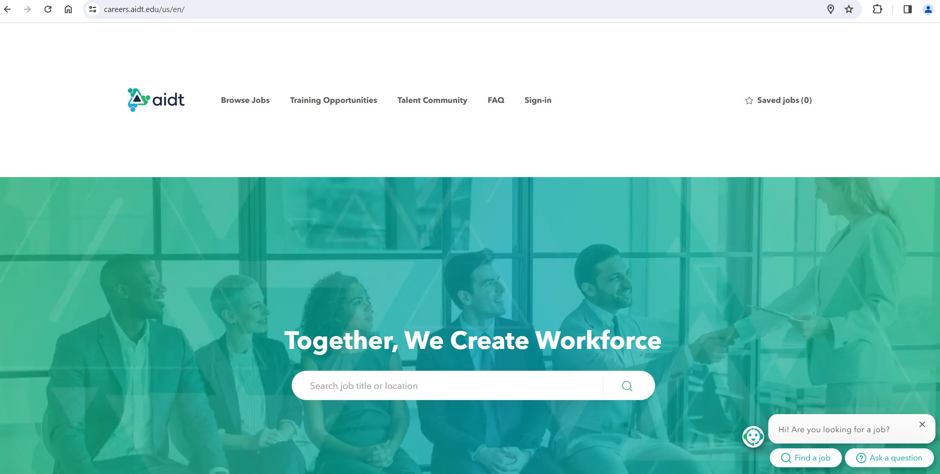

How to Tap Into Bioscience Technician Talent Pool – Step 2

Using AIDT career website dashboard link (https://careers.aidt.edu ), click “Sign-In” on main page

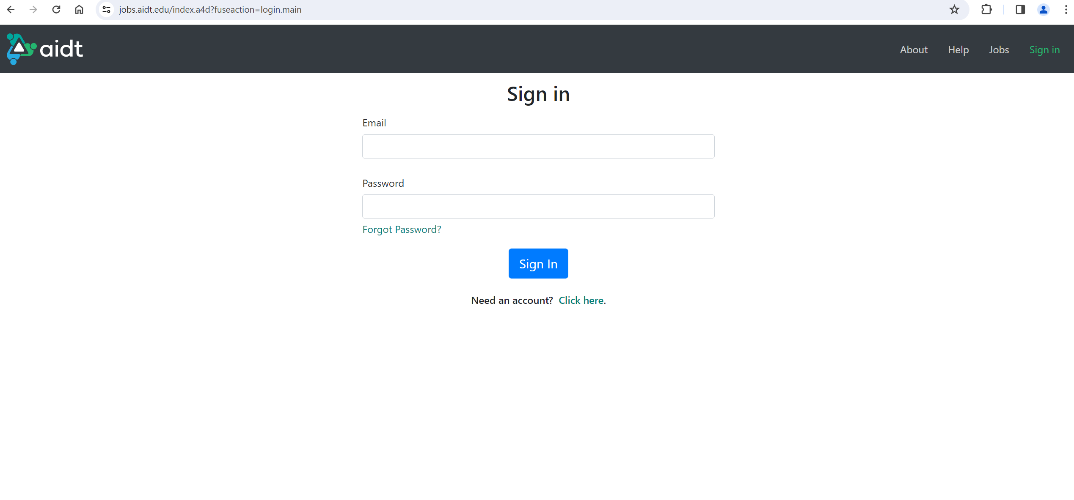
How to Tap Into Bioscience Technician Talent Pool – Step 2 (continued)

Enter the “Email/Username” and “Password” information provided by AIDT

How to Tap Into Bioscience Technician Talent Pool – Step 2 (continued)

There are 2 applicable options once on the jobs screen
Option 1 – Click on “Technicians”
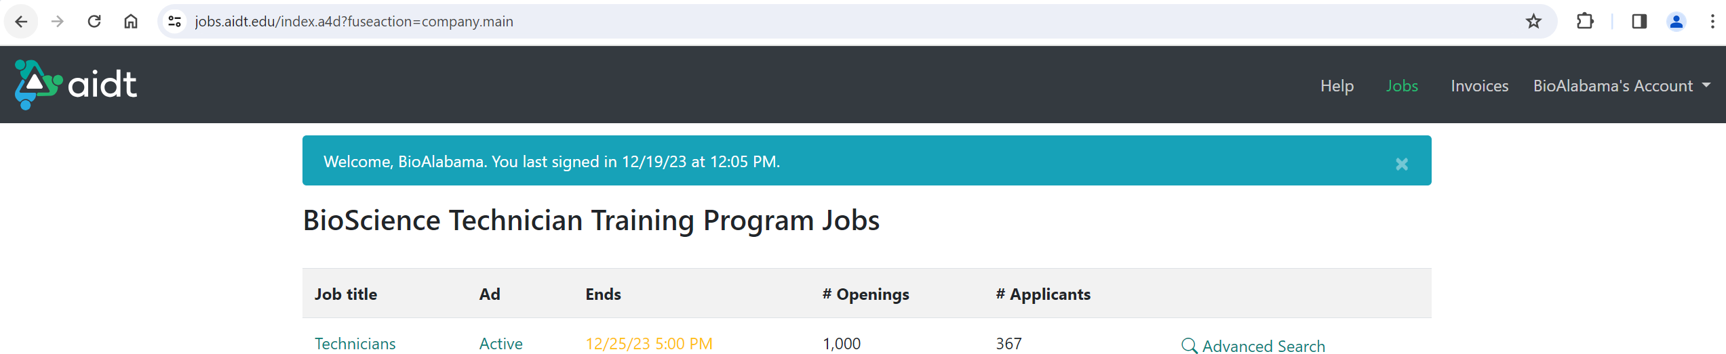

How to Tap Into Bioscience Technician Talent Pool – Step 2 (continued)

Change the “Status” from “Completed” to “All”
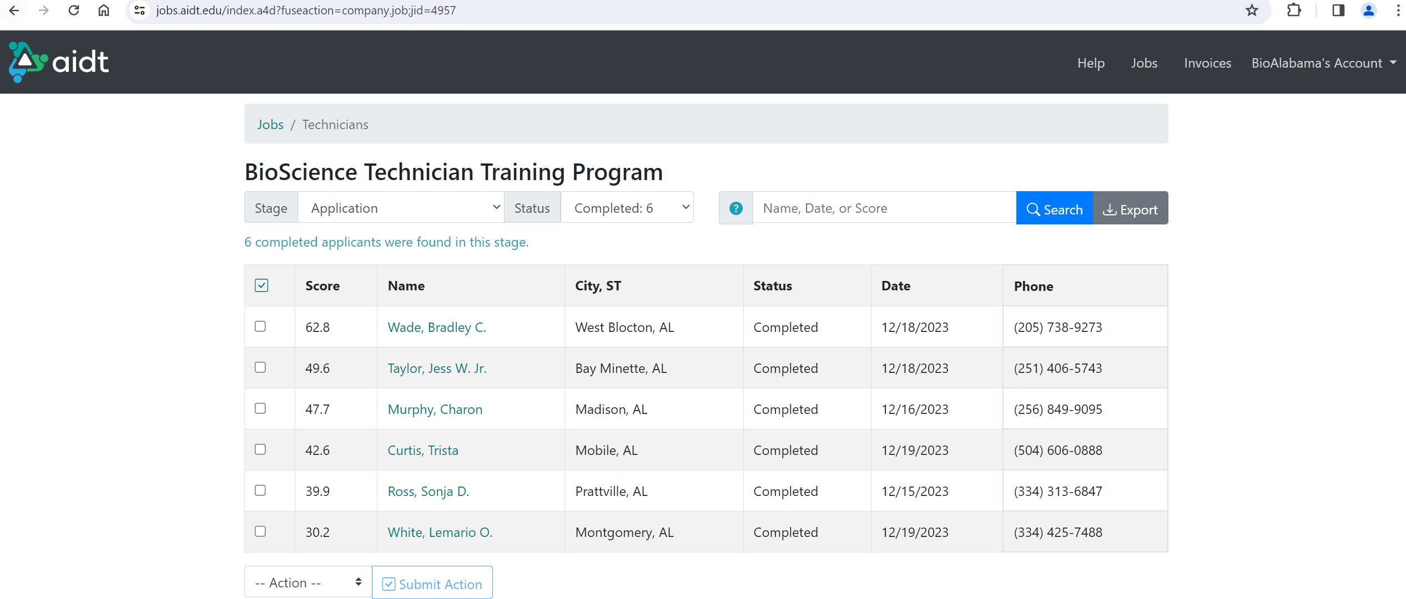

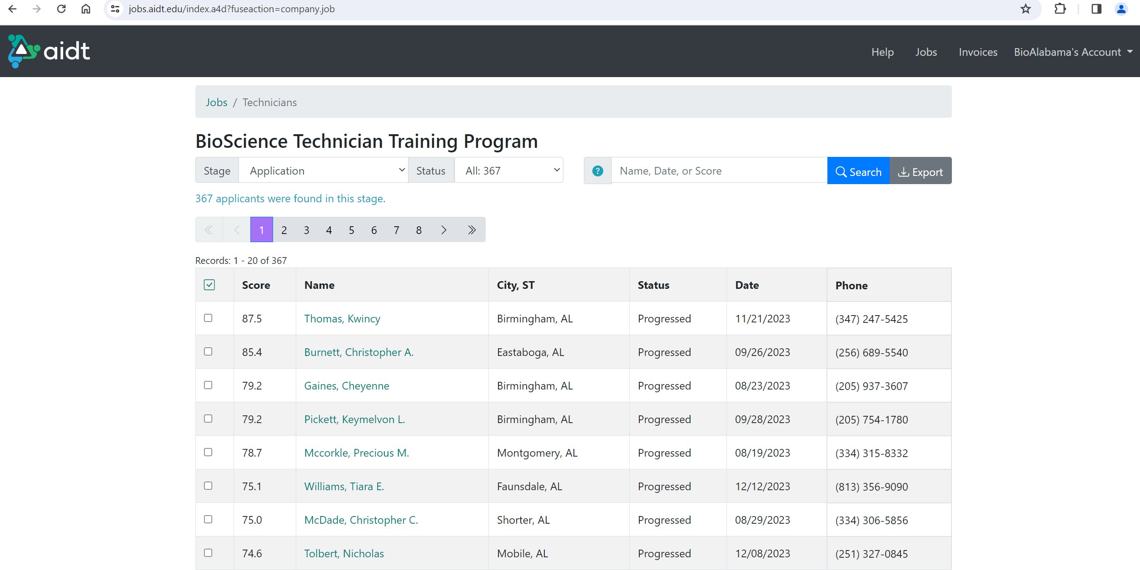

How to Tap Into Bioscience Technician Talent Pool – Step 2 (continued)

All applicants will now be displayed
- A search by “Name, Date, or Score” is possible
- “Score” is not the application training module test score; The reflected score is based on how a series of industry-generated registration questionnaires were answered (more on the registration questions AND how to tie-in the application training module scores will be explained in subsequent slides)

How to Tap Into Bioscience Technician Talent Pool – Step 2 (continued)

Additional drill-downs on individual applicants is also possible
- For example, click on “Burnett, Christopher A.” for a review of the individual’s application

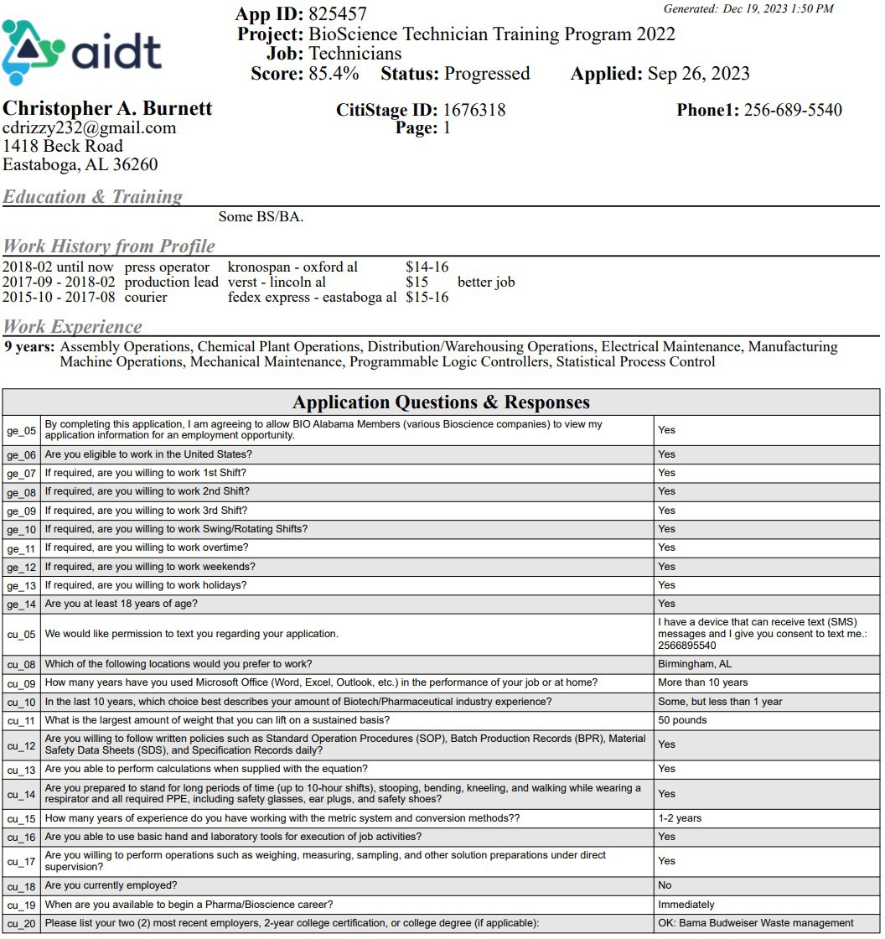

How to Tap Into Bioscience Technician Talent Pool – Step 2 (continued)

Application contains answers to industry-generated questions (see below), email, phone number, etc.

Industry-generated questions; e.g., Are you willing to work 2nd shift, 3rd shift, weekends, etc.

How to Tap Into Bioscience Technician Talent Pool – Step 2 (continued)

There are 2 applicable options once on the main screen
Option 2 – Click on “Advanced Search”

How to Tap Into Bioscience Technician Talent Pool – Step 2 (continued)

“Advanced Search” allows a search utilizing the industry-generated questions/skills/experience referenced in the previous slide; e.g., search for all individuals with at least 6 years electrical maintenance experience
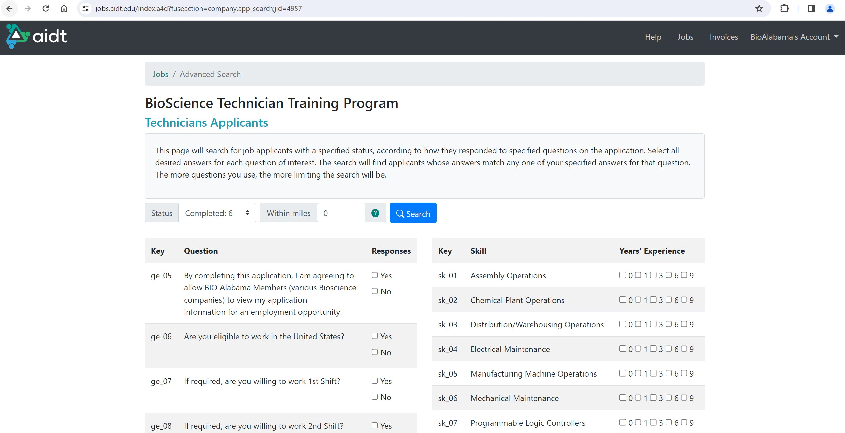
Make sure to change “Status” to “All” for the most comprehensive search
Use Step 3 (next slide) to tie dashboard info to applicant’s comprehensive module test score

How to Tap Into Bioscience Technician Talent Pool – Step 3

Access to the Adobe Learning Manager is required to tie the AIDT career website dashboard to the applicant’s comprehensive module test score (or vice-versa)
Learning Manager access can be requested from Tonya Keebler at AIDT (tkeebler@aidt.edu)
Comprehensive module test scores for all applicants are provided in a daily email containing an attached easy-to-use Excel spreadsheet (Bottom Tab “2-LP-Bioscience Technician Pre”)
Cross-reference names from the AIDT dashboard with the Learning Manager to compare comprehensive module test score results
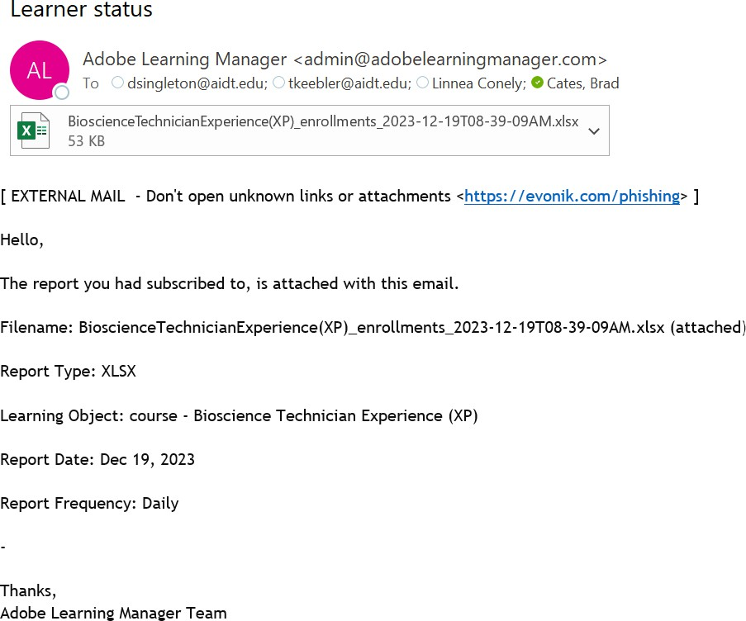
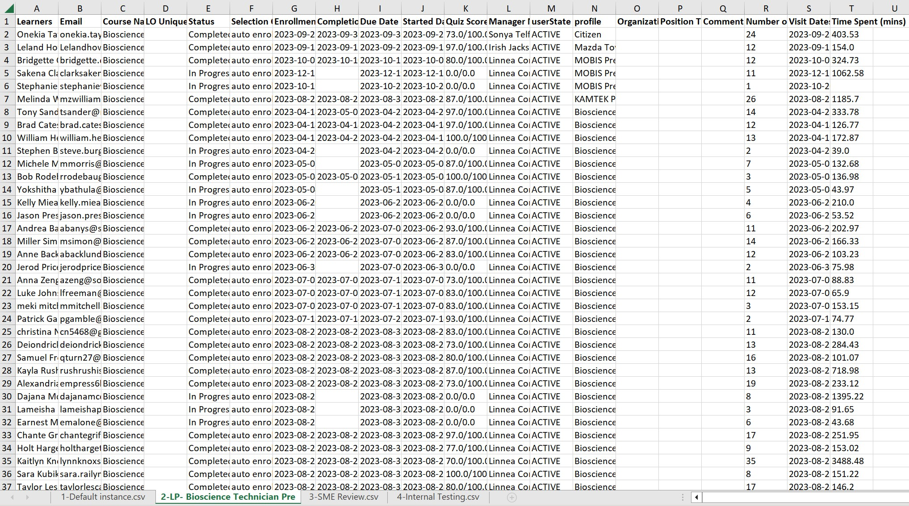

How to Tap Into Bioscience Technician Talent Pool – Summary

In 3 easy steps, tap into a ready-made pool of local, home-grown, vetted applicants
- Applicants with the willingness to complete the registration process
- Applicants with the self motivation and determination to carry through a 3-hour learning module
- Applicants with the aptitude to pass a comprehensive test with a passing grade of 70 or better

The more companies reach into the pool, interview candidates, and make hires, the more successful the program becomes, the more momentum generated for next steps (2-year college curriculums/degrees, 4-year college involvement)

Provide feedback through BIO Alabama (administrator@bioalabama.com) – Communicate your successful hires so successes can be measured!

aidt | presentation
THANK YOU

.

